APIs (Application Programming Interfaces)

🧾 What Is an API?
# Source: AI Source: Provided by: [Data Path: Persons Table -> ID Column: 1, Name_En Column: Motasem Essam] -> From: [ChatGPT] on [2/12/2026]
An API is a bridge that allows different software systems to communicate with each other.
👉 It lets one application request data or services from another.

✅ Simple Definition:
# Source: AI Source: Provided by: [Data Path: Persons Table -> ID Column: 1, Name_En Column: Motasem Essam] -> From: [ChatGPT] on [2/12/2026]
An API is a set of rules and endpoints that allow a client (like a browser or app) to interact with a server.

🧠 Real-Life Analogy:
# Source: AI Source: Provided by: [Data Path: Persons Table -> ID Column: 1, Name_En Column: Motasem Essam] -> From: [ChatGPT] on [2/12/2026]
Think of an API like a waiter in a restaurant 🍽️:
● You (client) → place an order
● Waiter (API) → takes your request
● Kitchen (server) → prepares the food
● Waiter → brings you the response
👉 You don’t talk directly to the kitchen — only through the waiter (API)

🔁 How APIs Work
# Source: AI Source: Provided by: [Data Path: Persons Table -> ID Column: 1, Name_En Column: Motasem Essam] -> From: [ChatGPT] on [2/12/2026]
- 👤 Client sends a request to an API endpoint
- 🌐 Request goes through HTTP
- ⚙️ API processes the request on the server
- 📦 Server retrieves or modifies data
- 📥 API sends back a response (usually JSON)

📍 What Is an API Endpoint?
# Source: AI Source: Provided by: [Data Path: Persons Table -> ID Column: 1, Name_En Column: Motasem Essam] -> From: [ChatGPT] on [2/12/2026]
An endpoint is a URL where the API is accessed.
Example:
https://api.example.com/users
👉 This endpoint could return a list of users

⚙️ Example API Request
# Source: AI Source: Provided by: [Data Path: Persons Table -> ID Column: 1, Name_En Column: Motasem Essam] -> From: [ChatGPT] on [2/12/2026]
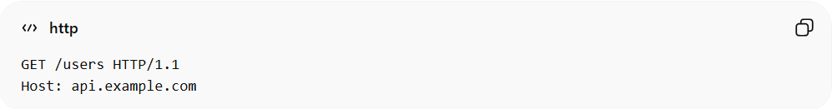
GET /users HTTP/1.1
Host: api.example.com
👉 Requesting user data from the API

📥 Example API Response (JSON)
# Source: AI Source: Provided by: [Data Path: Persons Table -> ID Column: 1, Name_En Column: Motasem Essam] -> From: [ChatGPT] on [2/12/2026]
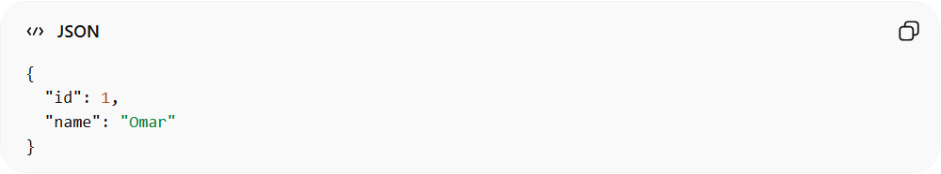
{
"id": 1,
"name": "Omar"
}
👉 Server responds with structured data

🔗 Types of APIs

🔹 1. REST API
# Source: AI Source: Provided by: [Data Path: Persons Table -> ID Column: 1, Name_En Column: Motasem Essam] -> From: [ChatGPT] on [2/12/2026]
● Most common type
● Uses HTTP methods (GET, POST, PUT, DELETE)
● Uses JSON format

🔹 2. SOAP API
# Source: AI Source: Provided by: [Data Path: Persons Table -> ID Column: 1, Name_En Column: Motasem Essam] -> From: [ChatGPT] on [2/12/2026]
● Uses XML
● More strict and structured
● Used in enterprise systems

🔹 3. GraphQL API
# Source: AI Source: Provided by: [Data Path: Persons Table -> ID Column: 1, Name_En Column: Motasem Essam] -> From: [ChatGPT] on [2/12/2026]
● Client asks for exactly what it needs
● Flexible and efficient

📦 API + HTTP Methods
# Source: AI Source: Provided by: [Data Path: Persons Table -> ID Column: 1, Name_En Column: Motasem Essam] -> From: [ChatGPT] on [2/12/2026]
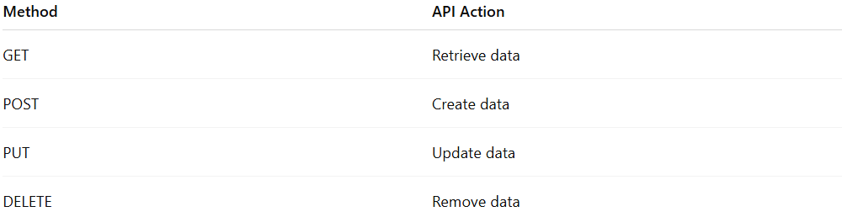
Method | API Action
GET | Retrieve data
POST | Create data
PUT | Update data
DELETE | Remove data
👉 APIs rely heavily on HTTP methods

🧾 API + Data Formats
# Source: AI Source: Provided by: [Data Path: Persons Table -> ID Column: 1, Name_En Column: Motasem Essam] -> From: [ChatGPT] on [2/12/2026]
● APIs usually use JSON
● Data is sent and received in structured format
👉 Example:
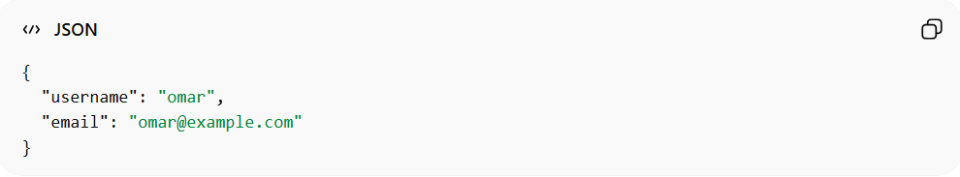
{
"username": "omar",
"email": "omar@example.com"
}

🔐 API Authentication
# Source: AI Source: Provided by: [Data Path: Persons Table -> ID Column: 1, Name_En Column: Motasem Essam] -> From: [ChatGPT] on [2/12/2026]
APIs often require authentication using:
● Tokens (JWT)
● API Keys
● OAuth
👉 Example:
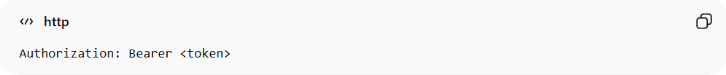
Authorization: Bearer <token>

💻 Simple PHP API Example
# Source: AI Source: Provided by: [Data Path: Persons Table -> ID Column: 1, Name_En Column: Motasem Essam] -> From: [ChatGPT] on [2/12/2026]
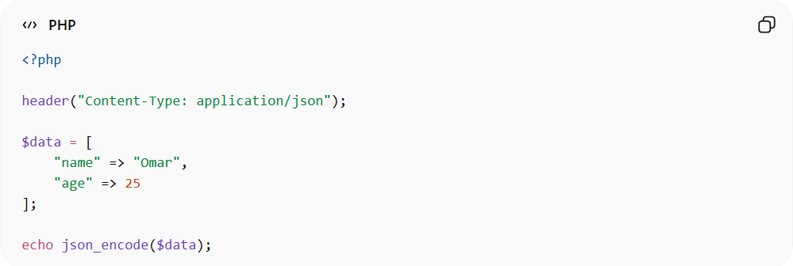
<?php

header("Content-Type: application/json");

$data = [
"name" => "Omar",
"age" => 25
];

echo json_encode($data);
● Sets response type to JSON
● Returns data to client

⚔️ API vs Direct Communication
# Source: AI Source: Provided by: [Data Path: Persons Table -> ID Column: 1, Name_En Column: Motasem Essam] -> From: [ChatGPT] on [2/12/2026]
Without API:
❌ Systems cannot talk easily
With API:
✅ Structured and secure communication

🎯 Key Idea
# Source: AI Source: Provided by: [Data Path: Persons Table -> ID Column: 1, Name_En Column: Motasem Essam] -> From: [ChatGPT] on [2/12/2026]
👉 API = messenger between systems
👉 It defines how applications talk to each other

🎓 Final Mental Model
# Source: AI Source: Provided by: [Data Path: Persons Table -> ID Column: 1, Name_En Column: Motasem Essam] -> From: [ChatGPT] on [2/12/2026]
● API = waiter
● Client = customer
● Server = kitchen
● Request = order
● Response = food

🔗 How It Connects to Everything You Learned
# Source: AI Source: Provided by: [Data Path: Persons Table -> ID Column: 1, Name_En Column: Motasem Essam] -> From: [ChatGPT] on [2/12/2026]
● HTTP → communication protocol
● Methods → actions (GET, POST…)
● Data Formats → structure (JSON)
● Headers → metadata (token, content-type)
● Tokens → authentication
👉 API uses ALL of these together 🔥

